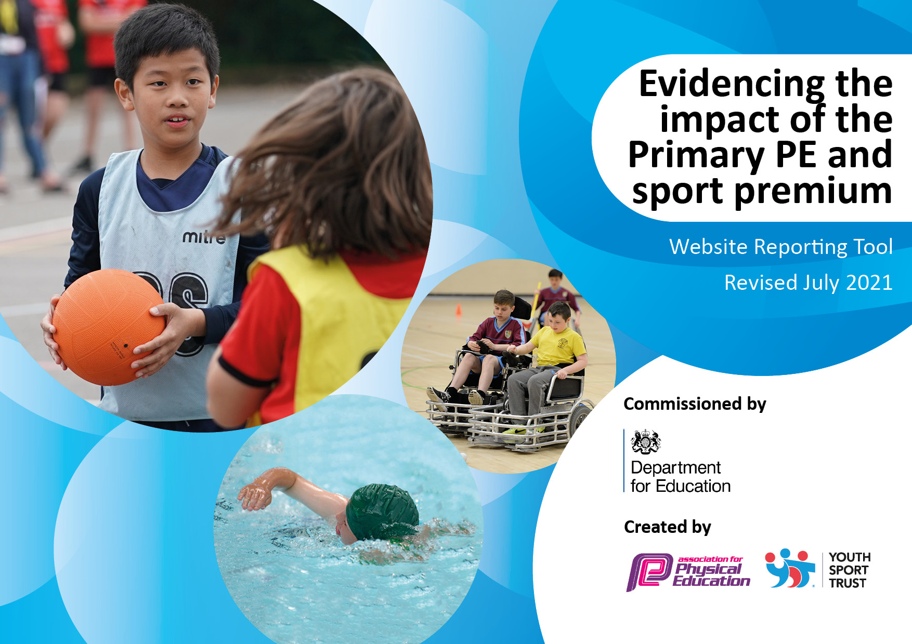
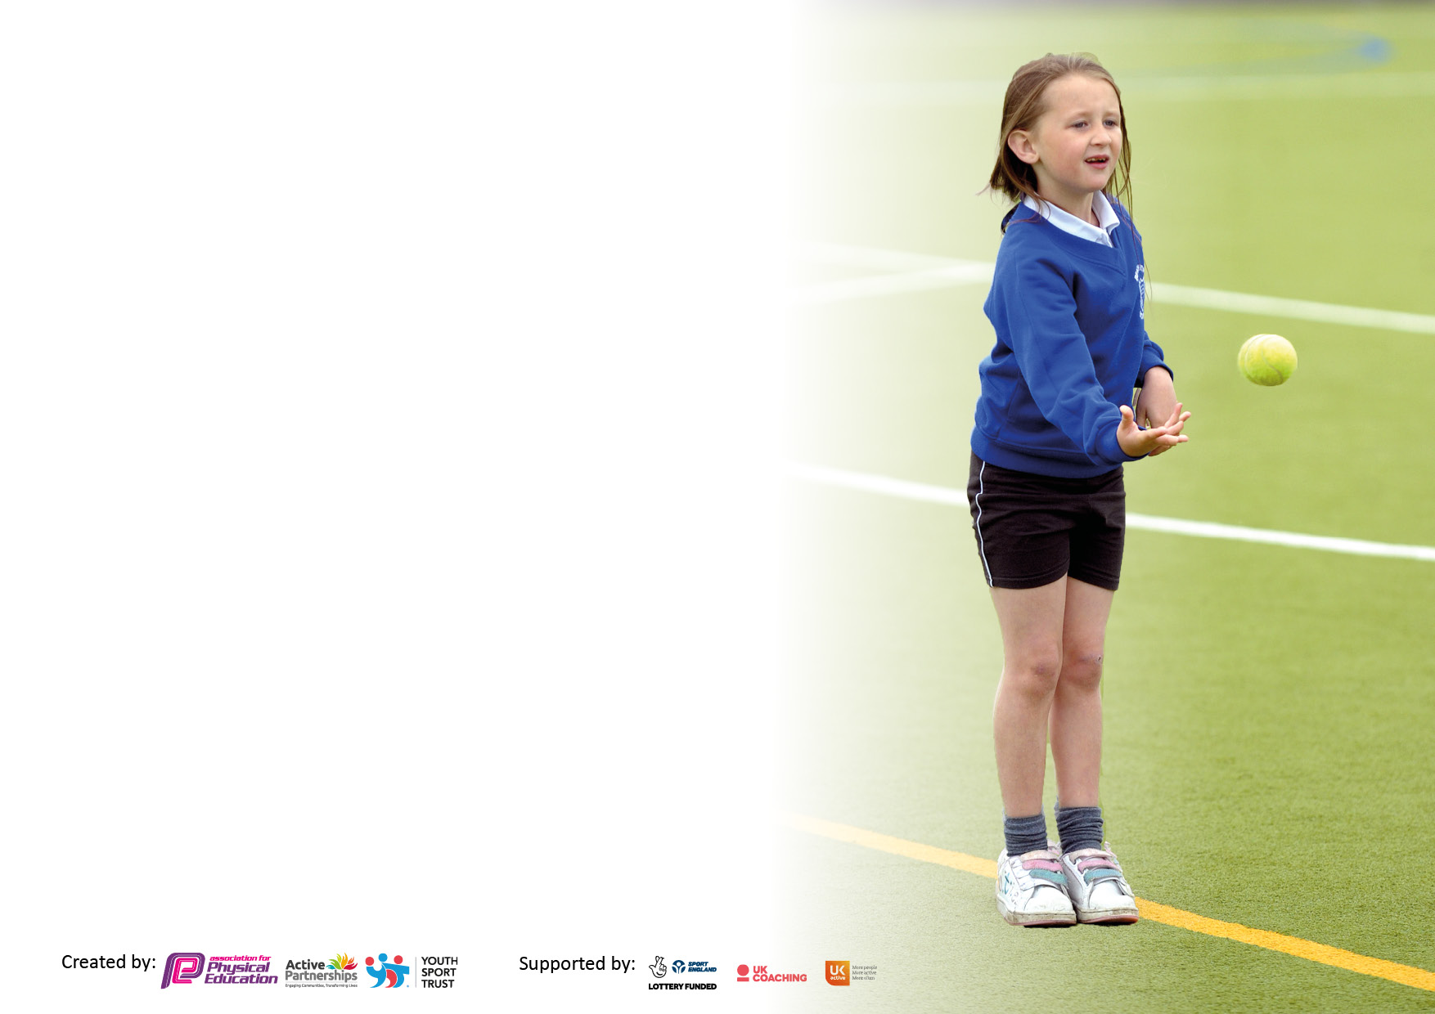

It is important that your grant is used effectively and based on school need. The Education Inspection Framework makes clear there will be a focus on ‘whether leaders and those responsible for governors all understand their respective roles and perform these in a way that enhances the effectiveness of the school’.

Under the Quality of Education Ofsted inspectors consider:
Intent - Curriculum design, coverage and appropriateness
Implementation - Curriculum delivery, Teaching (pedagogy) and Assessment
Impact - Attainment and progress

To assist schools with common transferable language this template has been developed to utilise the same three headings which should make your plans easily transferable between working documents.

Schools must use the funding to make additional and sustainable improvements to the quality of Physical Education, School Sport and Physical Activity (PESSPA) they offer. This means that you should use the Primary PE and sport premium to:

- Develop or add to the PESSPA activities that your school already offer
- Build capacity and capability within the school to ensure that improvements made now will benefit pupils joining the school in future years
- The Primary PE and sport premium should not be used to fund capital spend projects; the school’s budget should fund these.

Pleasevisitgov.ukfortherevisedDfEguidanceincludingthe5keyindicatorsacrosswhichschoolsshoulddemonstrate animprovement.Thisdocumentwillhelpyoutoreviewyourprovisionandtoreportyourspend.DfEencouragesschools to use this template as an effective way of meeting the reporting requirements of the Primary PE and sport premium.

We recommend you start by reflecting on the impact of current provision and reviewing the previous spend.

Schools are required to publish details of how they spend this funding, including any under-spend from 2019/2020, as well as on the impact it has on pupils’ PE and sport participation and attainment. All funding must be spent by 31st July 2022.

We recommend regularly updating the table and publishing it on your website throughout the year. This evidences your ongoing self-evaluation of how you are using the funding to secure maximum, sustainable impact. Final copy must be posted on your website by the end of the academic year and no later than the 31st July 2021. To see an example of how to complete the table please click HERE.

Details with regard to funding
Please complete the table below.

Total amount carried over from 2019/20 | £0
Total amount allocated for 2020/21 | £0
How much (if any) do you intend to carry over from this total fund into 2021/22? | £0
Total amount allocated for 2021/22 | £19,680
Total amount of funding for 2021/22. To be spent and reported on by 31st July 2022. | £19,680
Swimming Data
Please report on your Swimming Data below.

Meeting national curriculum requirements for swimming and water safety.

N.B. Complete this section to your best ability. For example you might have practised safe self-rescue techniques on dry land which you can then transfer to the pool when school swimming restarts.
Due to exceptional circumstances priority should be given to ensuring that pupils can perform safe self rescue even if they do not fully meet the first two requirements of the NC programme of study
What percentage of your current Year 6 cohort swim competently, confidently and proficiently over a distance of at least 25 metres? | %
What percentage of your current Year 6 cohort use a range of strokes effectively [for example, front crawl, backstroke and breaststroke]? | %
What percentage of your current Year 6 cohort perform safe self-rescue in different water-based situations? | %
Schools can choose to use the Primary PE and sport premium to provide additional provision for swimming but this must be for activity over and above the national curriculum requirements. Have you used it in this way? | Yes/No

Action Plan and Budget Tracking
Capture your intended annual spend against the 5 key indicators. Clarify the success criteria and evidence of impact that you intend to measure to evaluate for pupils today and for the future.

Academic Year: 2020/21 | Total fund allocated: | Date Updated:
Key indicator 1: The engagement of all pupils in regular physical activity – Chief Medical Officers guidelines recommend that primary school pupils undertake at least 30 minutes of physical activity a day in school |  |  |  | Percentage of total allocation:
 |  |  |  | £6500 /£19680 = 33%
Intent | Implementation |  | Impact
Your school focus should be clear what you want the pupils to know and be able to do and about  what they need to learn and to  consolidate through practice: | Make sure your actions to achieve are linked to your intentions: | Funding allocated: | Evidence of impact: what do pupils now know and what can they now do? What has changed?: | Sustainability and suggested next steps:
Engaging curriculum based on Sporting Influence.  Ensuring all children are following the PE scheme of work and that as a Federation, we are contributing to the national guidelines of 30 minutes of physical activity a day.  Access to high quality resources during after school clubs.  Enough quantity of resources to enable access for all  Access to increased range of high-quality resources to facilitate active play  Purchase of resources that facilitate active play in EYFS and the outdoor areas | Employment of qualified coaches to enhance the delivery of the NC  Outdoor equipment/groups to be deployed during break and lunchtime  Purchase of additional PE resources to support after school club sessions ad active play e.g. Balls/Racquets. Plus a widening of resources to allow additional sports to be covered in clubs and active play | £2,500  £2000  £2000 | Children are engaged when participating in PE.  Children using the new resources effectively.  Able to participate in a range of sporting activities.  Pupils understand the need for repeated and exerted activity if they wish to make improvements to their general fitness levels.  EYFS framework priorities are met | Develop a programme for the use of the outdoor spaces across TMF.  Continue to use CPD to address areas if the PE curriculum.  Develop bespoke curriculum for PE based on needs of children post COVID

Key indicator 2: The profile of PESSPA being raised across the school as a tool for whole school improvement |  |  |  | Percentage of total allocation:
 |  |  |  | £7230/£19680 = 37%
Intent | Implementation |  | Impact
Your school focus should be clear what you want the pupils to know and be able to do and about  what they need to learn and to  consolidate through practice: | Make sure your actions to achieve are linked to your intentions: | Funding allocated: | Evidence of impact: what do pupils now know and what can they now do? What has changed?: | Sustainability and suggested next steps:
For physical activity to be a key part of everyday school life  For there to be an explicit expectation that all children enjoy and achieve.  Improved access to resources and training for staff will lead to improved behaviour at playtimes  Improve children’s Emotional and Mental wellbeing through external workshops  SEND children are planned for and lessons and clubs facilitate full engagement of all children | Provide a broader range of after school sports clubs for pupils of all ages including: Football, Cricket, Athletics and Dance  Continue to purchase and replace sports equipment as per rota.  Purchase appropriate clothing for sporting events.  Lunch time supervisors to receive appropriate training and follow up planning time  Book in a series of workshops which include Ballet, Tai Chi and Qigong for Year 3 to Year 6 cohorts to improve concentration, health and mental wellbeing  Supply cover to enable Subject leader days £180x3 | £1790  £1500  £400  £0  £3000 Contribution  £540 | Children discussing and acting upon the key teaching points of PA and PE and the benefit to them.  Promote local sporting clubs. | Continue to review the teaching of swimming and explore the opportunity of teaching swimming across all of LKS2 (including cost).  Attend events through JESS Cluster Sporting Partnership when applicable

Key indicator 3: Increased confidence, knowledge and skills of all staff in teaching PE and sport |  |  |  | Percentage of total allocation:
 |  |  |  | £550/£19680 = 3%
Intent | Implementation |  | Impact
Your school focus should be clear | Make sure your actions to | Funding | Evidence of impact: what do | Sustainability and suggested
what you want the pupils to know | achieve are linked to your | allocated: | pupils now know and what | next steps:
and be able to do and about | intentions: |  | can they now do? What has
what they need to learn and to |  |  | changed?:
consolidate through practice:
For staff to take opportunities to plan and deliver active lessons working alongside sporting influence ensuring children receive high quality teaching  NQTs to receive bespoke training as part of their NQT induction programme  SOW to be developed fit for use across TMF | Ensure that PE lessons are delivered to a high standard and staff are provided with CPD opportunities throughout the year  SOW to be implemented | Part of JESS package  £550 | All pupils experience high quality PE lessons | Increased opportunities for extra-curricular activities. (inhouse)  Develop a plan for external events when possible  Staff to lead PE lessons under the guidance of PE lead developing their confidence in planning high quality sessions

Key indicator 4: Broader experience of a range of sports and activities offered to all pupils |  |  |  | Percentage of total allocation:
 |  |  |  | 1500/19680 = 7%
Intent | Implementation |  | Impact
Your school focus should be clear | Make sure your actions to | Funding | Evidence of impact: what do | Sustainability and suggested
what you want the pupils to know | achieve are linked to your | allocated: | pupils now know and what | next steps:
and be able to do and about | intentions: |  | can they now do? What has
what they need to learn and to |  |  | changed?:
consolidate through practice:
To expose pupils, regardless of ability, to a range of diverse activities during and outside of the school day.  Year 6 children offered Bikeability cycling training leading to increased confidence when riding bikes on roads and general cycling skills | Provide a broader range of after school sports clubs for pupils of all ages including: Football, Athletics, Dance, Cheerleading and Martial Arts.  OAA to be developed across TMF  Bikeability provided to all Year 6 pupils  Bike/ stores to be implemented | See above  £1500  FREE  £0 | Pupils exposed to OAA and given the opportunity to develop their own ability level.  Higher level of pupils travelling to school via bike. | Continue to seek links with residential places such as Lineham Farm, for Year 5 and 6 children  Provide sporting opportunities including cycling, climbing, archery, orienteering and adventure walking

Key indicator 5: Increased participation in competitive sport |  |  |  | Percentage of total allocation:
 |  |  |  | £3900/£19680 = 20%
Intent | Implementation |  | Impact
Your school focus should be clear | Make sure your actions to | Funding | Evidence of impact: what do | Sustainability and suggested
what you want the pupils to know | achieve are linked to your | allocated: | pupils now know and what | next steps:
and be able to do and about | intentions: |  | can they now do? What has
what they need to learn and to |  |  | changed?:
consolidate through practice:
Competitive sport taking place regularly in school | Provide a broader range of after school sports clubs for pupils of all ages including: Football, Athletics, Dance, Cheerleading and Martial Arts  School minibus to be used throughout TMF  Jess Cluster Partnership | See above cost  £2000  £1900 | Lessons are structured to include a competitive element when appropriate  External competitions take place twice per half term when available  Sports day planned in advance | JESS Cluster Sporting Partnership to be maintained in future

Signed off by
Head Teacher:
Date:
Subject Leader:
Date:
Governor:
Date:

