Phase: | Led by:
Lower Key Stage 2 | Louisa Milner

Context Statement:
The data capture is from Autumn term 1
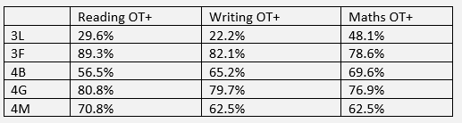
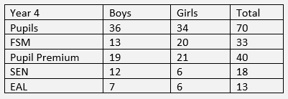
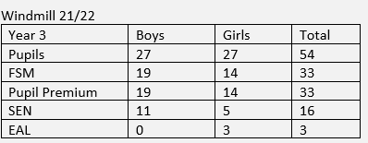

 | Reading OT+ | Writing OT+ | Maths OT+
Combined Year 3 | 61.1% | 53.7% | 64.8%
Baseline Year 3 | 57.4% | 50% | 64.8%
Combined Year 4 | 72.9% | 67.1% | 72.9%
Baseline Year 4 | 69% | 69% | 64.8%

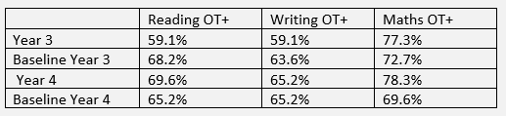
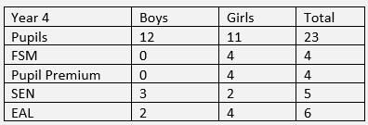
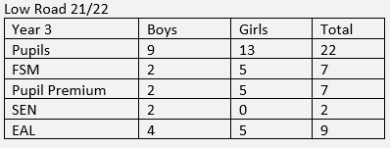

Windmill: There are four children within the Year 4 group who attend a morning group called Rainbow Group, this is led by Michelle Grimshaw. This is a small intensive group input which is very personalised to the needs of the pupils. They are currently working from the Year 2 maths curriculum and adapting the Year 3 English planning. There are also four other pupils who attend Sunshine group (SEND provision) on a morning. This is led by Gabby Mc Dermott and Teaching Assistants. They follow the same planning as the Rainbow group. There is a child with significant social, emotional or mental health (SEMH) needs that has been placed with the experienced Year 4 teacher. Currently, there are two ECT’s and an NQT and an RQT teaching in Lower Key stage 2.

Low Road: There are two strong teachers in Lower Key Stage 2, both having moved from Windmill. There are two pupils in Year 4, who are taught in a small supported group by Mrs Holderness. They are accessing the Year 3 curriculum.

Overview of Key Priorities:
- To increase engagement and attainment in reading
- Exit attainment of reading, writing and maths is at or above end of 2020-21 percentages. This includes the progress and attainment of SEND pupils
- To have consistently excellent behaviour in school
- To ensure the personal development of all pupils
- New practices to develop the curriculum are embedded
- Google Classroom is being used effectively to enrich, extend and promote independent learning.

Proposed Outcomes
- Pupils will read more regularly at home.
- Increased involvement of parents and carers in regard to their child’s reading.
- The number of pupils On Track or above increases, so that all pupils OT or above and a number of pupils who were JB at the end of 20-21 are all OT or above.
- All adults are aware of baselines and targets for pupils in their class or group. They provide necessary, appropriate and targeted support for any learner who requires it.
- Regular pupil progress meetings ensure all staff are aware of their pupils’ progress and intervention or target pupils or groups are identified and monitored over the half term.
- Learning behaviour is excellent.
- Pupils feel and express that behaviour in their class and school is excellent.
- Behaviour in areas outside the classroom is excellent. This includes on the playground.
- SLT work with all teaching staff to develop pupils in order to prepare them for life.
- Teachers and Teaching Assistants can make an early identification of pupils who may require additional personal support or development intervention.
- Learners are set aspirational end of year targets. All staff work to support and progress pupils to reach their maximum potential.
- Accelerated progress is made by those pupils who are identified for targeted support.
- Pupils GD at KS1 are identified and targeted to achieve GD in Lower Key Stage 2.
- Subject leaders to carry out deep dives and feed back to colleagues. Subject leaders and SLT monitor curriculum coverage and content through book and lesson scrutiny.
- Google classroom will be used regularly and effectively by all teachers and pupils.
- Homework and other tasks set on Google Classroom will promote academic and personal development.
- In the event of a lockdown, all pupils will be able to access online lessons.

Priority Developments | Actions | Resources & Costs | Personnel | Timescale
Quality of Education | Planning and teaching is consistently good or better. This will be done through:  - Regular book scrutinies and staff meetings to monitor that marking, feedback and presentation policies are being adhered to and are consistent across phase.  - Monitoring of children’s work to check that appropriate strategies are used to meet the needs of all learners.  - Planning is tailored to the specific needs of the class through planning scrutiny, drop-ins and lesson observations.  - Holding a weekly planning meeting in which the year group team will discuss their medium and short term lessons, sharing good practice and mentoring less experienced staff.  - Support new and current staff for planning and delivery of good and outstanding lessons.  - Rising Stars and Hamilton Trust are being used to inform dynamic planning in Foundation subjects.  - The mastery approach is well embedded in Mathematics.  - Learning environments support and inspire learners.  - A strong emphasis is put on spelling and handwriting so that children achieve ARE.  - Arrange peer observations to share good practice.  - Observe and monitor the use of TAs in classrooms, ensuring that they are aware of curriculum requirements and are regularly informed of the expected outcomes of the children that they are working with including SEND pupils and their personal learning targets.  - Ongoing training and development for Teaching Assistants. |  | SLT, Class Teachers and all support staff. | Ongoing
Behaviour and Attitudes | - Clear routines in the school and classroom  - Maintaining a strong focus on attendance and punctuality, including clear and effective attendance policies that all staff apply consistently and fairly  - All pupils are enjoying and developing their commitment to learning, enhancing their independent study skills and ensuring a ‘growth mindset’ which incorporates being resilient to setbacks and taking pride in their achievements.  - Adults make sure that all pupils feel safe in school and address any concerns they may have through discussion. Provide a worry box for pupils to post a note into. ‘Adults who can help me’ posters are displayed in the classroom and cloakroom environments.  - Through class PSHE lessons and at all other times of the day, relationships between teachers and pupils that reflect a positive and respectful culture.  - Adopt the zero tolerance for bullying, discrimination, sexual harassment, sexual abuse and sexual violence approach. Participate in anti-bullying week and regularly re-visit this topic for discussion within class time.  - All staff are familiar with the anti-bullying policy and that it is being adhered to.  - Staff to deal with issues quickly, consistently and effectively (whenever they occur) |  | Class Teachers, Support Staff and SLT | Ongoing
Personal Development | - Phase staff and SLT work together to prepare learners for life in modern Britain so that pupils are responsible, respectful and active citizens who are able to play their part and become actively involved in public life as adults.  - Pupils develop positive personal traits, reflect wisely and pupils’ confidence, resilience and knowledge means they can keep themselves mentally healthy through the carefully planned and delivered PSHE sessions. For some pupils, there will be an identified need for additional intervention such as nurture group or a referral for cluster support.  - Teachers and SLT will consider carefully the time and age appropriateness of SRE sessions, taking into account the pupils in each cohort.  - Every pupil has an understanding of online and offline risks and pupils will be aware of the support available to them. |  | Class Teachers, support staff, SLT including Safeguarding and nurture staff | Ongoing
Leadership and Management | - SLT enable staff to engage effectively with learners and others in the community including parents and carers.  - Promote safeguarding enabling the phase to effectively identify pupils who may need early help.  - SLT to identify CPD needs for the phase.  - Continue to develop team ethos ensuring that ECTs, NQTs and RQTs have a clear idea of school policies and practice.  - Encourage more experienced teachers to use their skill set to mentor NQTs , ECTs and RQTs wherever possible.  - More experienced teachers to become ECT or Peer Mentors.  - Support new teachers in the use of Arbor for daily tasks, formative and summative tracking and assessment.  • Hold regular planning meetings (virtual and face to face) to both pass on relevant information and to share good practice and outcomes.  • Develop staff through dialogue, coaching, mentoring and support.  - Classroom teaching, learning environments and work books are consistently good or better. This is identified through regular monitoring of books and lesson observations or drop-ins.  - All staff applying the marking and presentation policy correctly and are supported when required.  - Staff are supported in responding to feedback given by SLT after book monitoring.  - LKS2 Phase Leader to work closely with KS1 and UKS2 leaders to ensure that standards including the marking policy are consistent throughout the Federation.  - To support teachers to create an intervention timetable for targeted groups of children in order to close the gap towards national expectations.  - Teachers have a detailed awareness of the progress and needs of pupils in their class and group.  - Hold regular pupil progress meetings with class teachers and the assessment leader to identify and prove pupil progress as well as identify pupils that need targeted intervention.  - Work closely with Maths and English leaders (L. Galinsky and R. Evans) to monitor pupil outcomes.  - Work alongside NQT mentor, Rachael Troughton, to support the new to Federation teachers with teaching and learning, classroom environment, behaviour management and their ECT induction tasks. |  | SLT  Subject Leaders  Phase/ Team Leaders | Ongoing

