EYFS
Unit 1- Where do we live
Unit 2-How are special times celebrated?
Unit 3- What makes a good helper?
Unit 4- What can we see in our wonderful world?
Unit 5- Who and what are special to us
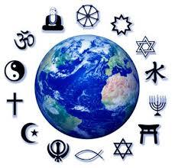

Year 1
Unit 1- Which books and stories are special?
Unit 2- Why we celebrate special events?
Unit 3- What does it mean to belong to a church or mosque?
Unit 4- How and why do we care?
Unit 5-Who brought messages from God and what did they say?

Year 2
Unit 1- How is new life welcomed?
Unit 2- How can we make good choices?
Unit 3- How and why do people pray?
Unit 4- How can we look after the planet?
Unit 5- What did Jesus teach and how did he live?

Year 3
Unit 1- How do Jews remember God’s covenant with Abraham and Moses?
Unit 2- How do people express spirituality?
Unit 3- What do Christians believe about a good life?
Unit 4- What do creation stories tell us?
Unit 5- Who can inspire us?

Year 4
Unit 1- How are important events remembered?
Unit 2- What faiths are shared in our country?
Unit 3- How do the five pillars guide Muslims?
Unit 4- Why are Gurus at the heart of Sikh belief and practice?

Year 5
Unit 1- Why are some journeys and places special?
Unit 2- What values are shown in codes for living?
Unit 3- Should we forgive others?
Unit 4-What do Christians believe about old and new covenants?

Year 6
Unit 1- How do Sikhs show commitment?
Unit 2- What do Christians believe about Jesus’ death and resurrection?
Unit 3-How does growing up bring responsibilities?
Unit 4- How do Jews remember the Kings and Prophets in worship and life?

