Parent Survey 2020
Covid-19 Closure Focus
Low Road and Windmill Music Federation

In March 2020, The Music Federation, were instructed to close the school to almost all children until further notice due to the global Covid-19 Pandemic.
As advised by the government, we will stayed open for the children of key workers (e.g. NHS staff, police, others in frontline services) and children with certain needs.

Pupils’ learning was of course important to us all, so we continued to help all children to learn throughout the closure.
We dynamically set up Google Classroom to ensure stability of provision in terms of tasks and activities accessible to all. Children were provided with a book and resource pack to record their activities and work. As you can imagine, implementing this on such a large scale and to so many families could be problematic, so we swiftly set up a dedicated support e-mail address for this along with all closure-related correspondence. Families without Internet access were provided with paper resources throughout the whole closure and those without devices were lent iPads upon request. The work packs were initially posted out and then, as time progressed, were included in the home visit rota. We actively encouraged all pupils to access their learning via Google Classroom and tapestry finding it to be highly successful.

From the very first day, Windmill became a hub providing meals to out FSM children and those from Broomfield and Hunslet Carr. Low Road were initially provided free meals from from Hunslet St. Josephs. The introduction of meal vouchers caused many internal issues, which were out of our control and heavily publicised in the press. We are proud to say that we continued providing meals and food hampers for those affected and finally resolved the issue and could arrange meal vouchers for the whole of the summer holiday. At all times, communication regarding the issue was shared with families via telephone calls, text messages and website letters.

The wellbeing of pupils and their families were at the forefront of our minds. Our website updates were plentiful and text messages sent directing families to view detailed updates. Vulnerable pupils were invited in to school, however the uptake was lower that government expectations. Consequently, our Designated Safeguarding Lead conducted weekly reviews of these pupils and all families had weekly telephone calls. Home visits were also arranged and the social distancing advice was adhered to throughout. There were many lines of communication between school and families: daily Google classroom checks made by staff; e-mail support and advice; weekly telephone calls from teachers and regular text message updates to name a few.

All families have been asked to comment on their own personal experience of how the leadership team has managed Low Road, Windmill and Daycare throughout the Covid 19 pandemic.

This anonymised (where appropriate) document contains online responses as of 6.7.2020

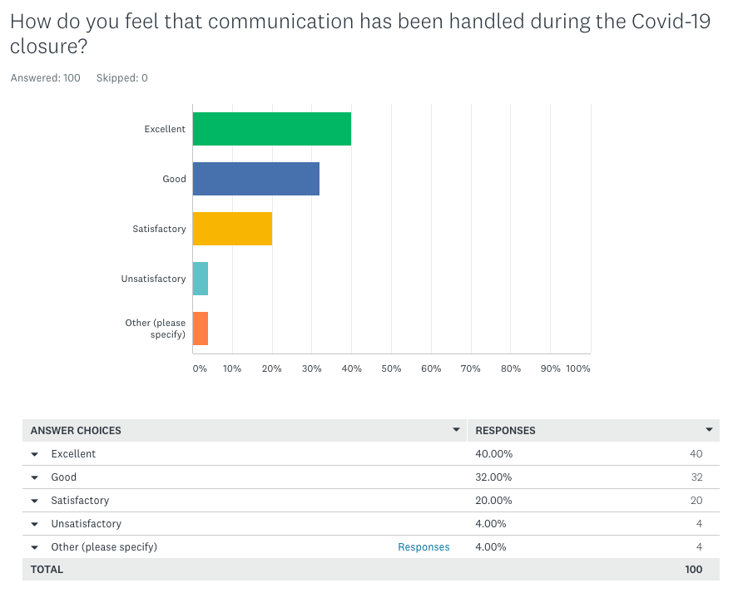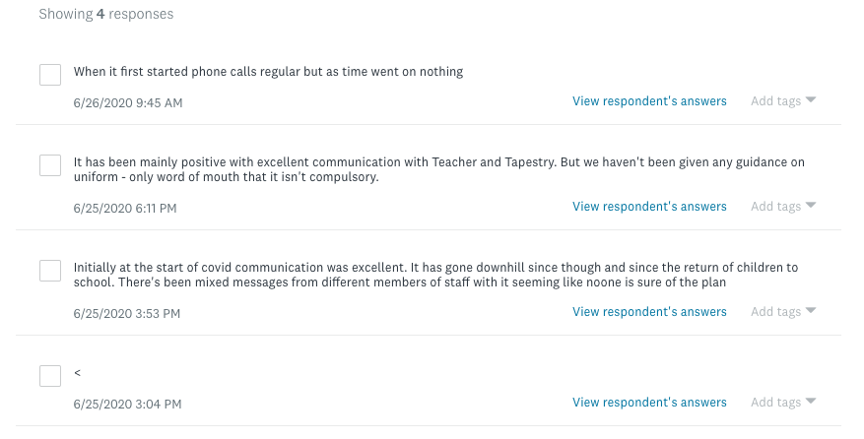

72% of families rate the communication Good/Excellent with an additional 20% saying it was satisfactory. When teachers conducted telephone calls, many were ringing offsite and therefore from private numbers. Staff were advised not to leave answerphone messages as it enabled the family to ring them back. Consequently, some families chose to not answer and received home visits.
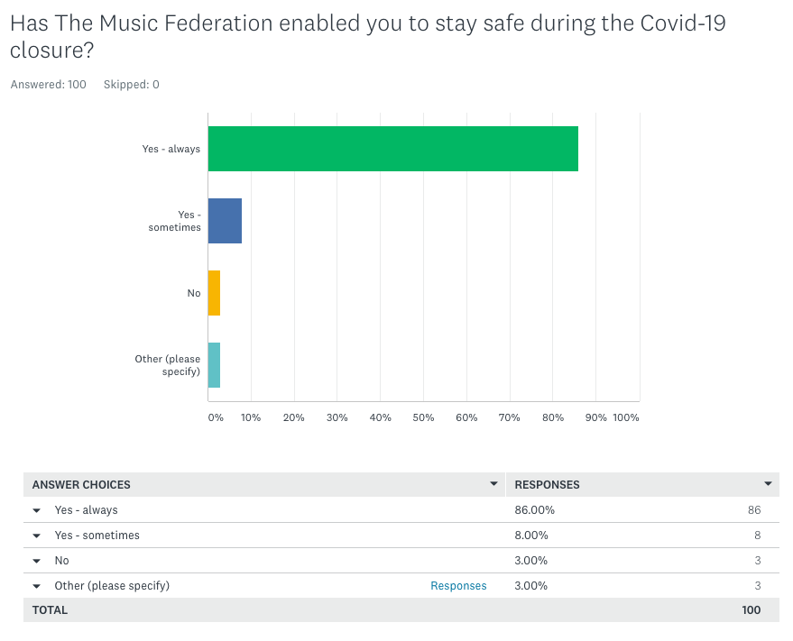

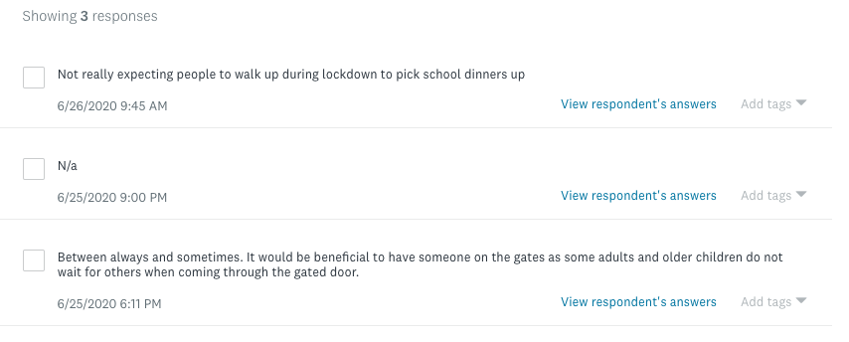

97% of the families felt like TMF helped them to stay safe. We did offer meals for our pupils, which did need collecting as we were unable to deliver to every individual family. Those who chose to use this service were happy to collect.
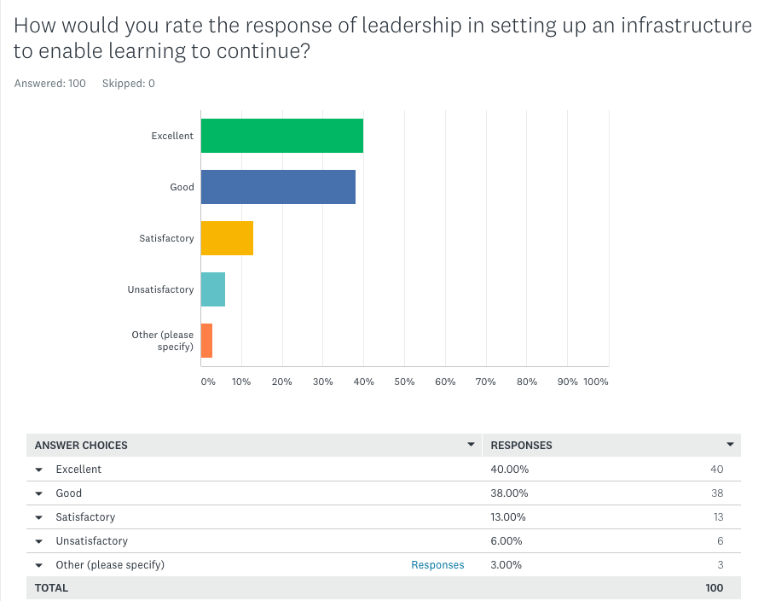

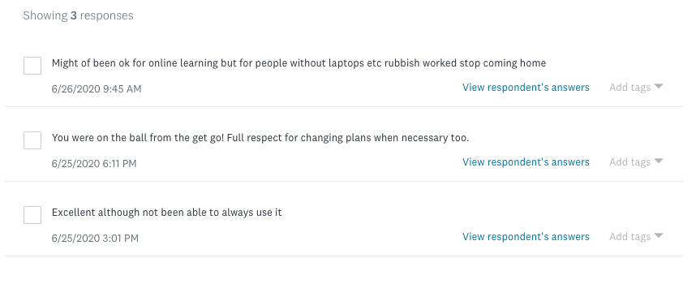

78% rated TMF as Good/Excellent when setting up home learning with a further 13% (taking the total to 91%) stating it was satisfactory. Those pupils who did not attend on the final day were unable to collect their packs/Usernames and passwords however these were posted out on Monday 23rd March. Government lockdown restrictions meant that they took longer to arrive than hoped.
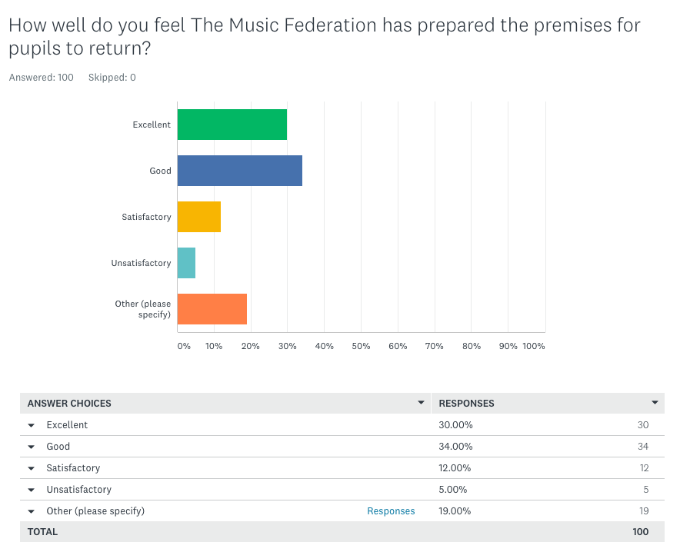

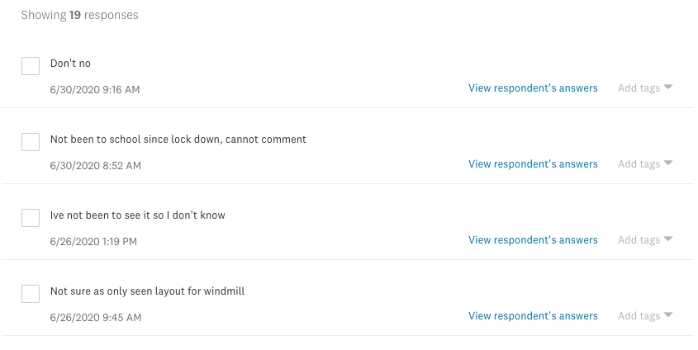

The results for this question are skewed due to 19% feeling unable to comment due to not returning to either school yet.
A video showing and explaining all the measures staff made towards meeting government guidelines was available to view online. A text message was sent to all parents directing them to the video for reassurance. As always, TMF continued to welcome feedback and questions regarding the premises; these came via e-mail and phone calls.

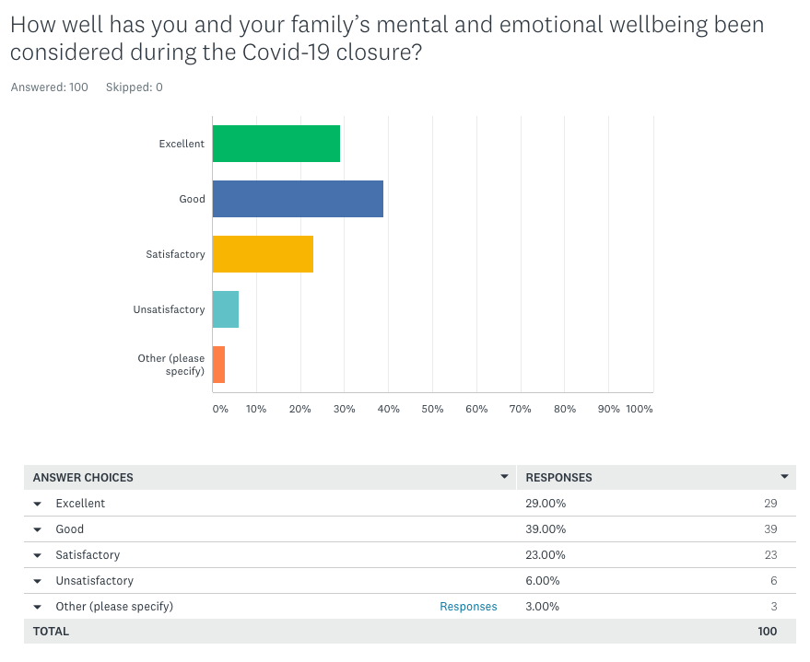

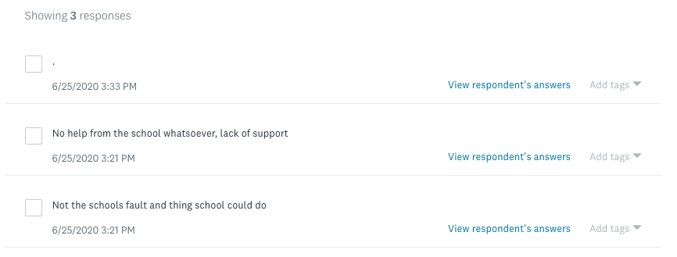

68% feel like we have provided Good/Excellent support towards mental and emotional wellbeing during the closure with a further 23% (taking the total to 91%) saying we have been satisfactory. From the way the results have been collected, we are unable to further discuss with the 6% who found us unsatisfactory. However, there was a space for comments at the end of the questionnaire.
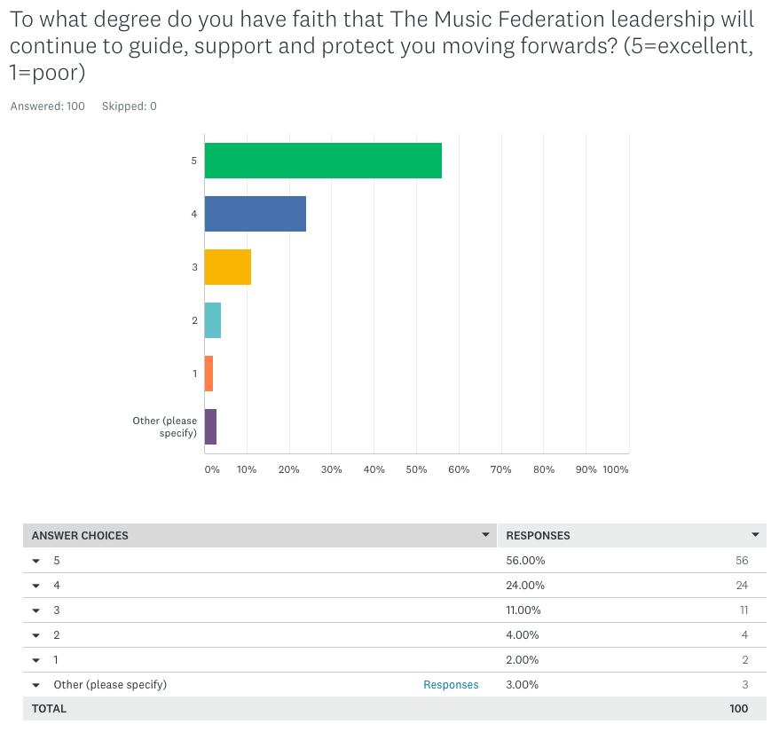

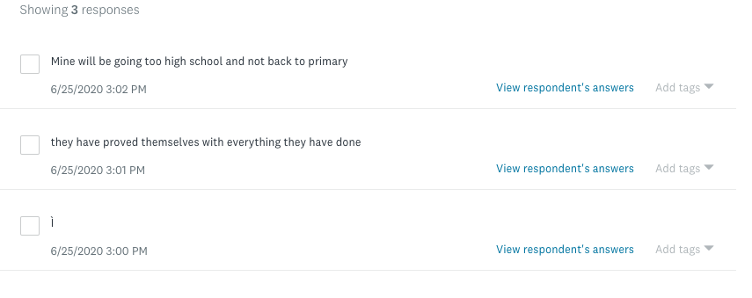

It is clear from this that the families have faith in our ability to continue to deliver an excellent service to the families moving forwards.
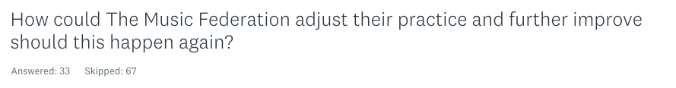
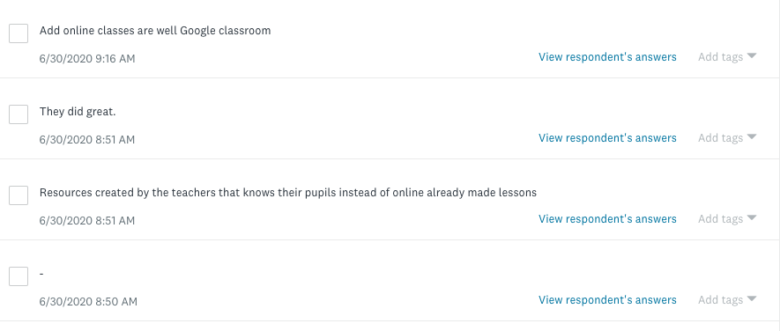

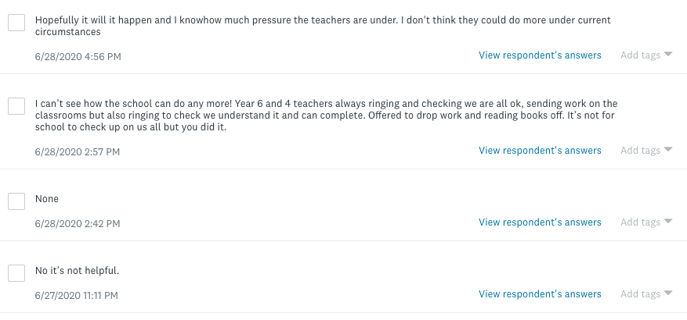

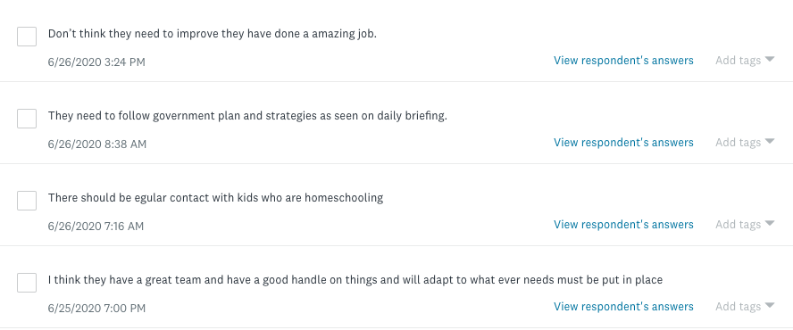

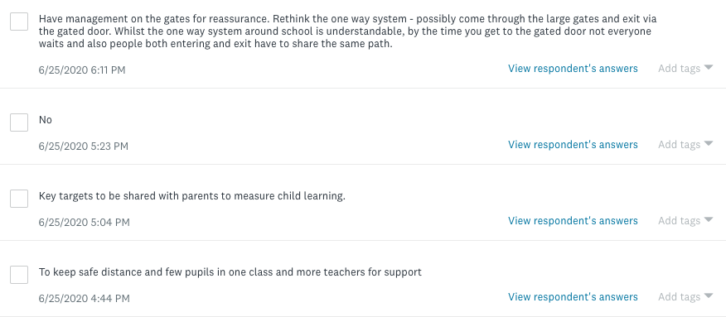
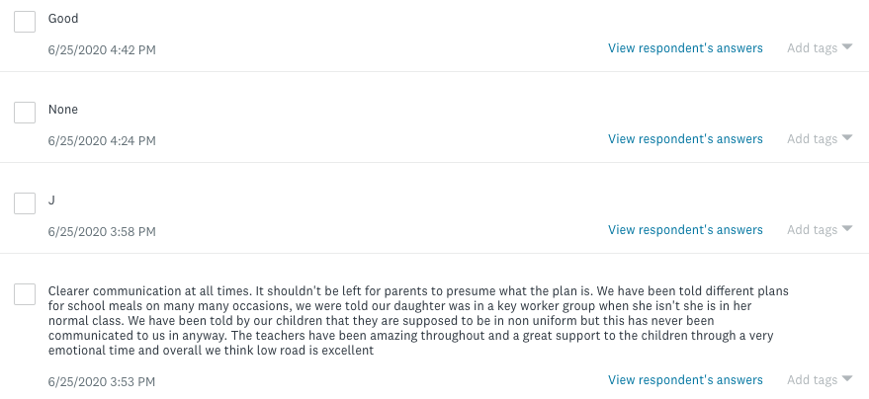

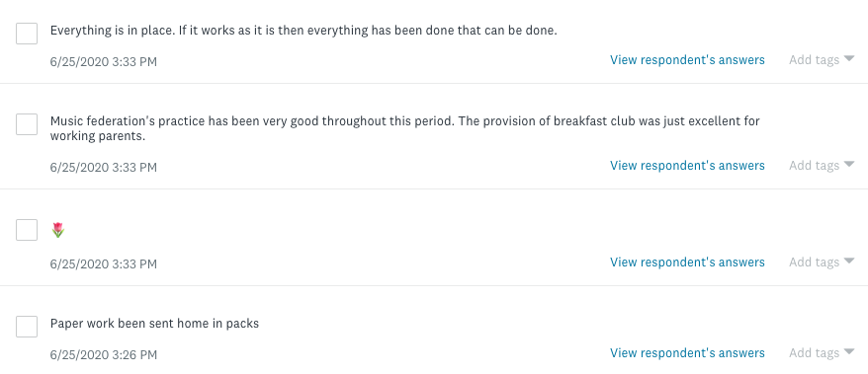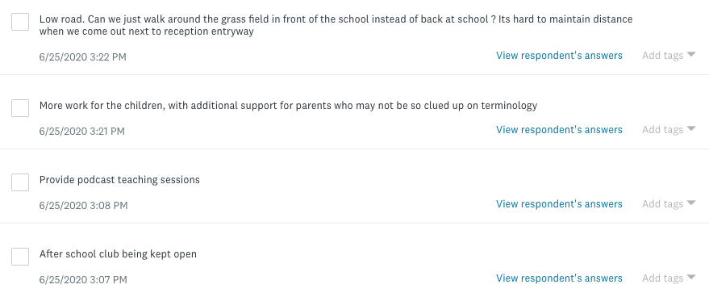

Some suggestions from parents were acted upon straight away such as having more staff on the gates when pupils return. This will continue into September when further opening occurs.
Online lessons and/or video lessons have also been suggested and this is something teams are happily exploring however we need to ensure we follow all federation policies linking to e-safety and safeguarding.

