RSE Policy
Jennifer Sharp
July 2020

We believe that every person has a fair and equal opportunity to succeed, regardless of their age, gender, ethnicity, ability or cultural or religious background, sexuality or disability. We embrace all aspects of global citizenship and community cohesion, promoting British Values throughout all aspects of school life, actively tackling prejudice or extreme views.

Our school is committed to safeguarding and promoting the wellbeing of all children, and expects other staff and volunteers to support this commitment. This policy is written in line with our agreed policy for GDPR.

The Music Federation SRE Policy

INTRODUCTION

The Music Federation takes its responsibility to provide relevant, effective and responsible SRE to all of its pupils as part of the school’s personal, social, health, economic (PSHE) curriculum very seriously. The school wants parents/carers and pupils to feel assured that SRE will be delivered at a level appropriate to both the age and development of pupils, and safe to voice opinions and concerns relating to the SRE provision.

High quality SRE helps create a safe school community in which our pupils can grow, learn and develop positive, healthy behaviour for life. It is essential for the following reasons:

- Children have a right to good quality education, as set out in the United Nations Convention on the Rights of the Child.
- Children want to be prepared for the physical and emotional changes they undergo at puberty, and young people want to learn about relationships. Older pupils frequently say that sex and relationships education was ‘too little, too late and too biological’. Ofsted reinforced this in their 2013 Not Yet Good Enough report.
- SRE plays a vital part in meeting the schools’ safeguarding obligations. Ofsted is clear that schools must have a preventative programme that enables pupils to learn about safety and risks in relationships.
- Schools maintain a statutory obligation under the Children Act (2004) to promote their pupils’ emotional wellbeing, and improving their ability to achieve in school and under the Education Act (1996) to prepare children for the challenges, opportunities and responsibilities of adult life.
- A comprehensive SRE programme can have a positive impact on pupils’ health and wellbeing and their ability to achieve, and can play a crucial part in meeting these obligations.
- Relationships Education is compulsory in all primary schools. Sex Education is not compulsory but it is expected that all primary schools provide age-appropriate knowledge and understanding. The content of these sessions will be communicated with parents and there will be opportunities for parents to speak with senior staff. Parents do have the right to withdraw their child from these specific Sex Education lessons (unless it is covering the statutory requirements of the National Curriculum for Science KS2).

Our definition of SRE

SRE education can be defined as a lifelong learning about physical, moral and emotional development. It is about the understanding of the marriage for family life, stable and loving relationships, respect, love and care. It is also about teaching sex, sexuality and sexual health.

The teaching of Sex and Relationships Education at The Music Federation, uses an integrated and consistent approach and is an important aspect of pupil’s education. Sex and Relationship educations includes supporting young people in developing self-confidence in preparing for physical and emotional changes into adulthood. We believe that the teaching of Sex and Relationship Education should be shared with parents and be mutually supportive and complementary. It promotes an understanding of the range of family types and other people who contribute to providing children with the care, love and support they need to grow and develop.

AIMS

Our approach to SRE consists of a comprehensive and developmental programme of teaching and learning, which is delivered in the context where the health and wellbeing of pupils and the whole school community are actively promoted. Our SRE programme has a positive influence on the ethos, learning and relationships throughout the school. It is central to our values and to achieving our school’s stated aims and objectives. Our SRE programme helps pupils to develop the knowledge, understanding, skills and attitudes they need to live confident, healthy, independent lives now and in the future.

Through the provision outlined in this policy, the school’s overall aims of SRE are to teach and develop the following three main elements as set out in SRE Guidance DfEE 2000:

- Attitudes and values:
- learn the importance of values and individual conscience and moral considerations
- learn the value of family life, marriage, and stable and loving relationships for the nurture of children
- learn the value of respect, love and care
- explore, consider and understand moral dilemmas
- develop critical thinking as part of decision-making

- Personal and social skills:
- learn to manage emotions and relationships confidently and sensitively
- develop self-respect and empathy for others
- learn to make choices based on an understanding of difference and with an absence of prejudice
- develop an appreciation of the consequences of choices made
- manage conflict
- learn how to recognise and avoid exploitation and abuse

- Knowledge and understanding:
- learn and understand physical development at appropriate stages
- understand human sexuality, reproduction, sexual health, emotions and relationships
- learn the reasons for delaying sexual activity, and the benefits to be gained from such delay, including the avoidance of unplanned pregnancy

In addition to this, we also aim to:

- raise pupils’ self-esteem and confidence
- develop communication and assertiveness skills that can help them stay true to their values if challenged by others, their peers or what they see in the media
- teach pupils to be accepting of the different beliefs, cultures, religions, sexual orientations, physical and mental abilities, backgrounds and values of those around them
- support pupils to lead a healthy and safe lifestyle, teaching them to care for, and respect, their bodies
- provide pupils with the right tools to enable them to seek information or support, should they need it
- teach pupils about the right to say no, in an age appropriate manner
- to teach lessons that are sensitive to a range of views, values and beliefs
- ensure that staff teaching SRE remain neutral in their delivery whilst ensuring that pupils always have access to the learning they need to stay safe, healthy and understand their rights as individuals

The aim of SRE is NOT to:
- encourage pupils to become sexually active at a young age
- promote a particular sexual orientation
- sexualise children

The SRE programme in school will relate to the schools overall PSHE provision and the wider curriculum of the school. It will:

- be an integral part of the lifelong learning process, beginning in early childhood and continuing into adult life
- be an entitlement for all pupils, including those with additional learning and language needs
- be set within the wider school context and support family commitment and love, respect and affection, knowledge and openness
- recognise that family is a broad concept; not just one model, e.g. nuclear family
- encourage pupils and teachers to share and respect each other’s views with cultural awareness and sensitivity
- ensure pupils are aware of different approaches to sexual orientation, without promotion of any particular family structure
- recognise that parents/carers are the key people in teaching their children about relationships, sex and growing up
- work in partnership with parents/carers and pupils, consulting them about the content of programme
- work in partnership with other health professionals (such as the staff nursing team to help support the delivery of Sex Education to Upper Key Stage 2)

SRE contributes to:
- a positive ethos and environment for learning
- safeguarding pupils (Children Act 2004), promoting their emotional wellbeing, and improving their ability to achieve in school
- a better understanding of diversity and inclusion, a reduction in gender-based and homophobic, biphobic, transphobic (HBT) prejudice, bullying and violence and an understanding of the difference between consenting and exploitative relationships
- helping pupils keep themselves safe from harm, both on and offline, enjoy their relationships and build confidence in accessing services if they need help and advice
- reducing early sexual activity, teenage conceptions, sexually transmitted infections, sexual exploitation and abuse, domestic violence and bullying

VALUES

Sex and Relationships Education is required to be taught within a moral framework. Children will learn about moral values through all aspects of school life and in all curriculum areas, not just in Sex and Relationships Education. This policy is based on our commitment to:

- Fairness
- Excellence
- Respectfulness

PROCEDURES AND PRACTISE

We teach SRE as part of our PSHE curriculum which by the end of KS2 pupils will be able to:

- express opinions, for example, about relationships and bullying
- listen to, and support others
- respect other people’s viewpoints and beliefs
- recognise their changing emotions with friends and family and be able to express their feelings positively
- identify adults they can trust and who they can ask for help
- be self-confident in a wide range of new situations, such as seeking new friends
- form opinions that they can articulate to a variety of audiences
- recognise their own worth and identify positive things about themselves
- balance the stresses of life in order to promote both their own mental health and well-being and that of others
- see things from other people’s viewpoints, for example their parents/carers and their carers
- discuss moral questions
- listen to, support their friends and manage friendship problems
- recognise and challenge stereotypes, for example in relation to gender
- recognise the pressure of unwanted physical contact, and know ways of resisting it

Pupils will know and understand:
- about the physical changes that take place at puberty, why they happen and how to manage them
- the many relationships in which they are all involved
- where individual families and groups can find help
- how the media impact on forming attitudes
- about keeping themselves safe when involved with risky activities
- that their actions have consequences and be able to anticipate the results of them
- about different forms of bullying people and the feelings of both bullies and victims
- why being different can provoke bullying and know why this is unacceptable
- about, and accept, a wide range of different family arrangements, for example second marriages, fostering, extended families and three or more generations living together

Pupils will have considered:
- the diversity of lifestyles
- others’ points of view, including their parents/carers’ or carers
- why being different can provoke bullying and why this is unacceptable
- when it is appropriate to take a risk and when to say no and seek help
- the diversity of values and customs in the school and in the community
- the need for trust and love in established relationships

We also teach SRE as part of the National Curriculum for Science which includes:

- describing the differences in the life cycles of a mammal, an amphibian, an insect and a bird
- describing the life process of reproduction in some plants and animals
- describing the changes as humans develop to old age

GROUND RULES

Staff are careful to ensure their personal beliefs and attitudes do not influence the teaching of SRE. To this end, ground rules have been put in place to provide a framework of common values within which to teach. There are clear parameters as to what will be taught in a whole-class setting, and what will be dealt with on an individual basis.

In addition to the ground rules used in PSHE, we will develop a set of non-negotiable rules for lessons and discussions related to SRE. If pupils are to benefit fully from an SRE programme, they need to be confident speakers, good listeners and effective, sensitive communicators. When the needs of pupils are analysed, of overriding importance are two key areas: they need to feel safe and be safe. A set of additional, non-negotiable ground rules will help staff to create a safe and relaxed environment in which they do not feel embarrassed or anxious about unexpected questions or comments from the pupils. They also reduce the possibility of inappropriate behaviour and the disclosure of inappropriate personal information.

(Appendix 3: Teacher Guidance on Ground Rules)

PARENT PARTNERSHIP

Our school recognises the key role that parents/carers fulfil in supporting their children through all aspects of growing up and therefore, we seek to work in partnership with parents/carers when planning and delivering SRE.

The school will encourage this partnership by:

- Keep parents/carers informed about the SRE curriculum, including when it is going to be delivered.
- Parent /carers’ views on the policy are taken into account.
- Providing access to resources and information being used in class and do everything to ensure that parents/carers are comfortable with the education provided to their children in school.
- Expect parents/carers to share the responsibility of SRE and support their children’s personal, social and emotional development.
- Encourage parents/carers to create an open home environment where pupils can engage, discuss and continue to learn about matters that have been raised through SRE.
- Provide support and encourage parents/carers to seek additional support in this from the school where they feel it is needed.

APPENDICES

There are appendices to this policy:
Appendix 1: Terminology and language.
Appendix 2: How staff will answer questions.
Appendix 3: Teacher guidance on Ground Rules.
Appendix 4: LTP for PSHE including SRE

Appendix 1 Terminology and Language

Pupils will be taught the anatomical terms for body parts. Slang or everyday terms used in certain social circles will be discussed; this will surround discussions about what is and isn’t acceptable language to use. This can be shared with parents/carers before the content is delivered to the pupils.

Appendix 2 How staff will answer questions.

We acknowledge that sensitive and potentially difficult issues will arise in SRE as pupils will naturally share information and ask questions. When spontaneous discussion arises, it is guided in a way that reflects the stated school aims and curriculum content for SRE. As a first principle, we answer questions relating to taught, planned curriculum for that age group to the whole class. We answer questions relating to areas beyond the taught, planned curriculum for that age group, in a sensitive and age appropriate way, only to the pupil or pupils who have asked the question. If a member of staff is uncertain about the answer to a question, or indeed whether they should answer it, they will seek guidance from the PSHE leader/ Child Protection Officer/ Head Teacher. Questions may be referred to parents/carers if it is not appropriate to answer them in school. We may use a question box where questions may be asked.

When answering questions, we ensure that sharing personal information by adults, pupils or their families is discouraged. Where a question or comment from a pupil in the classroom indicates the possibilities of abuse or risk of harm, teachers will pass this information to the designated person for safeguarding and child protection, in line with school policy and procedures.

Staff training will include sessions on how to deal with difficult questions. Agreed phrases, where appropriate, will be used in response to difficult questions [for example, ‘I can only answer question on the content of this lesson’ or ‘That is something that may be covered later on’ or ‘I can’t answer that question, but you could ask your parents/carers’]

Ground rules are essential when discussing sensitive subject matters. Staff will establish clear parameters about what is appropriate and inappropriate in a whole-class setting by for example:

- staff will set the tone by speaking in a matter-of-fact way
- pupils will be encouraged to write down questions, anonymously if desired, and post them in an ask-it basket
- staff will have time to prepare answers to all questions before the next session, and will choose not to respond in a whole-class setting to any questions that are inappropriate or need one-to-one follow up
- if a verbal question is too personal, staff will remind the pupils of the ground rules
- if a question is too explicit, feels too old for a pupil, is inappropriate for the whole class, or raises concerns, staff will acknowledge it and promise to attend to it later on an individual basis
- staff will not provide more information than is appropriate to the age of the pupil
- if staff are concerned that a pupil is at risk of abuse, the designated teacher will be informed and the usual child protection procedures followed

Appendix 3 Teacher Guidance on Ground Rules

Our additional, non-negotiable ground rules for SRE are:

Conversations that take place within the classroom are dealt with in a confidential manner. However, if anyone mentions something which could be harmful or may put them at risk – then we will have to pass the information on to help keep them safe
- It’s not okay to ask personal questions of each other or the teacher but we can put questions in the box for later.
- Don’t name names: if you want to ask about or share a personal story or experience, you can speak in the third person about ‘someone I know’, ‘a friend’, ‘a situation I’ve heard about/read about’
- We will try to only ask questions related to what we are learning in the lesson.
- We will use the anatomical terms for the sexual body parts.
- It is okay to say pass or not join in.
- We will respect different opinions, situations & backgrounds.

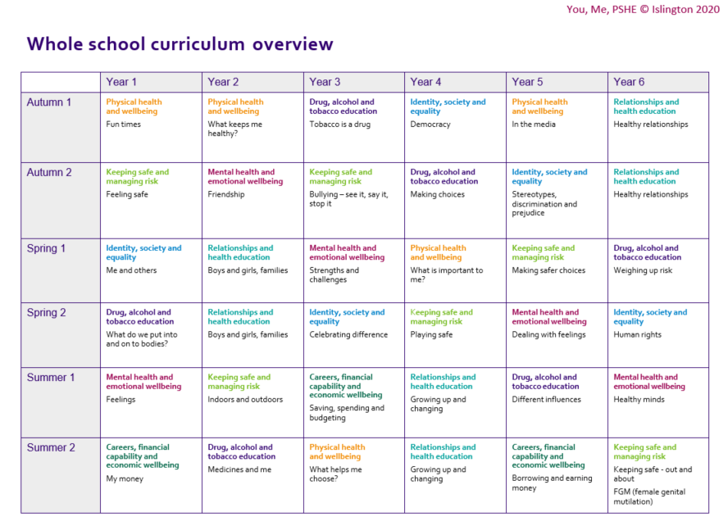
Appendix 4 Long Term Plan for PSHE which includes SRE

